The Fun Happy Cute Loveable Widdle

ANIMALS BONUS!

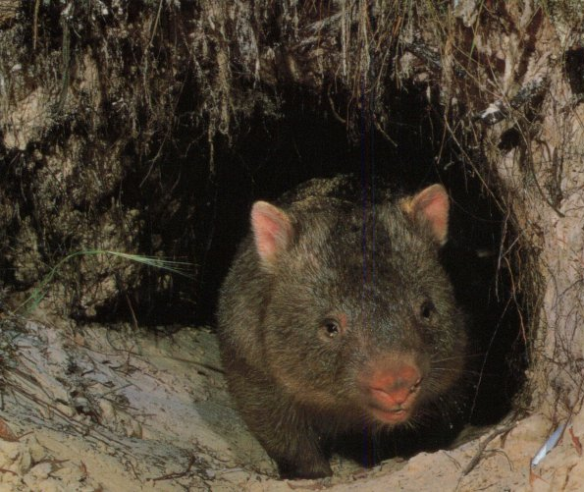

Fig. 1a- The Fearsome Mortal Wombat

Section I-

Identify the dog breeds from their pictures
1. 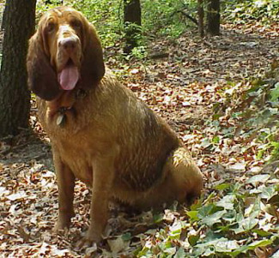

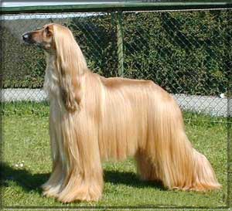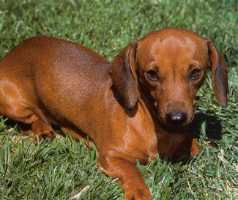
2. 3.

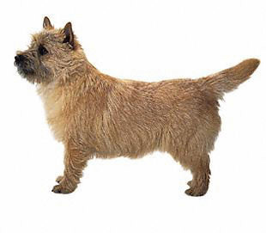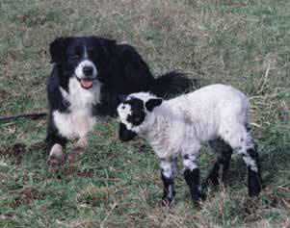

4.5.

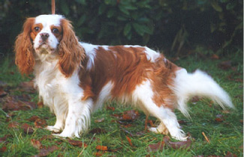

6.7.

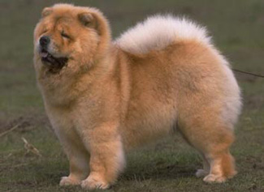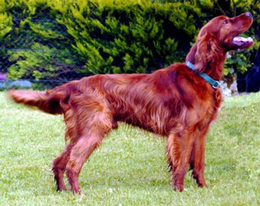
8.9.

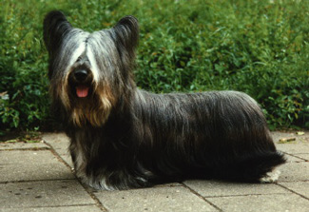
10. 11.

Section II-

Identify the non-domestic cats from their pictures

12.

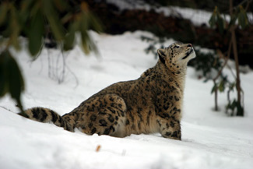

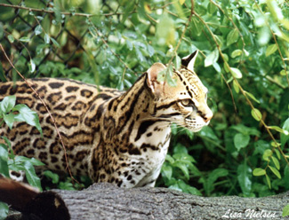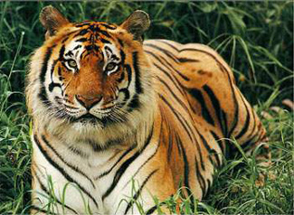
13. 14.

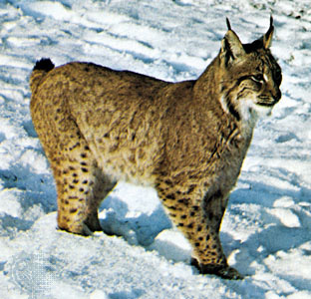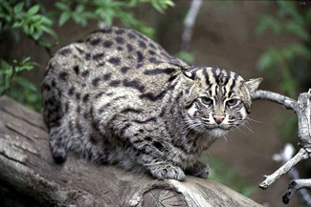
15. 16.
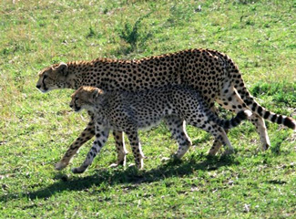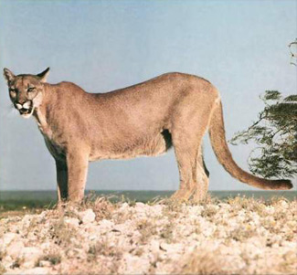
17.18.

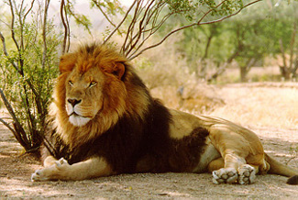
19.
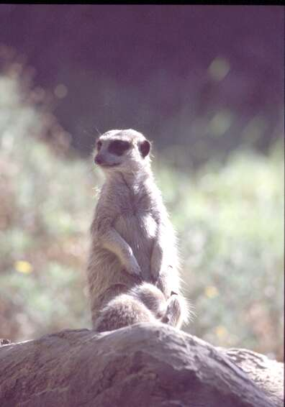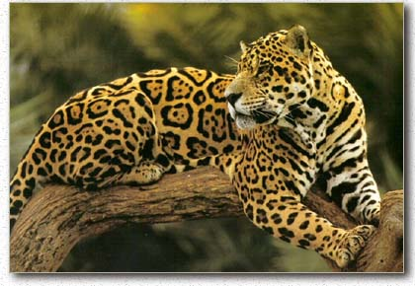
20. 21.

Section III-

What are the differences between these pairs of similar/often-confused animals?

22. Porcupines and Hedgehogs

23. Seals and Sea Lions

24. Newts and Salamanders

25. Alligators and Crocodiles

26. Mountain Lion and Cougar

27. Rabbit and Hare

Section IV-

Give the common names (not Latin names, that’s just too easy for Google to come up with) of the animals with these unusual or superlative features-

28. The earliest known bird (i.e., feathers, teeth, no beak)?

29. The lizard with three eyes?

30. The snake whose fangs are greatest in length?

31. The most deadly frog?

32. The largest brain of any animal?

33. The deadliest octopus?

34. The shortest vertebrate?

35. The fish with the longest snout?

36. The most primitive living breed(s) of dog?

37. The smallest mammal (it’s full, official common name, please)?

38. Biggest species of deer?

39. The bird with the most feathers (the official common name)?

40. The bird with the biggest bill?

41. The swiftest animal alive?

42. The fastest bird in flight (i.e., without gravitational assistance)?

43. The bird that can stay in the air the longest?

44. The only bird with a sideways-curving bill?

45. The most poisonous spider (i.e. most potent venom)?

46. The furthest jumping frog?

47. The fastest swimming fish?

48. The mammal with the most babies?

49. The animal with the biggest eyes?

50. The shortest snake?

Section V-

Name the following animals, as specifically as possible, from their pictures, and then tell us what they have in common (adding in the supporting details which should be obvious if you’ve figured out the theme).

1. 2.3.

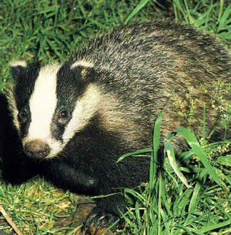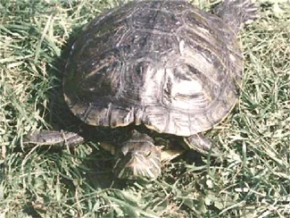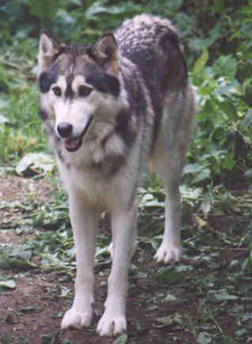

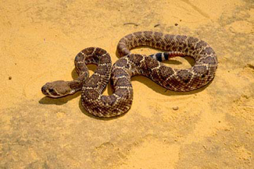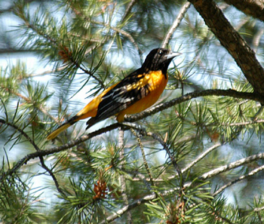
4.5.

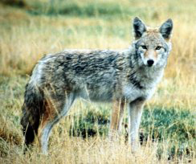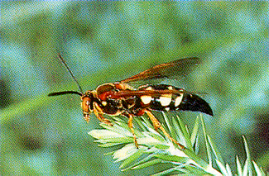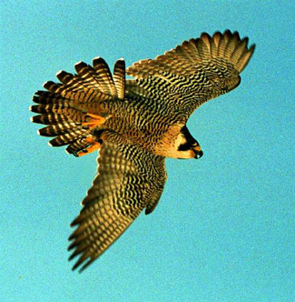

6. 7.8.

